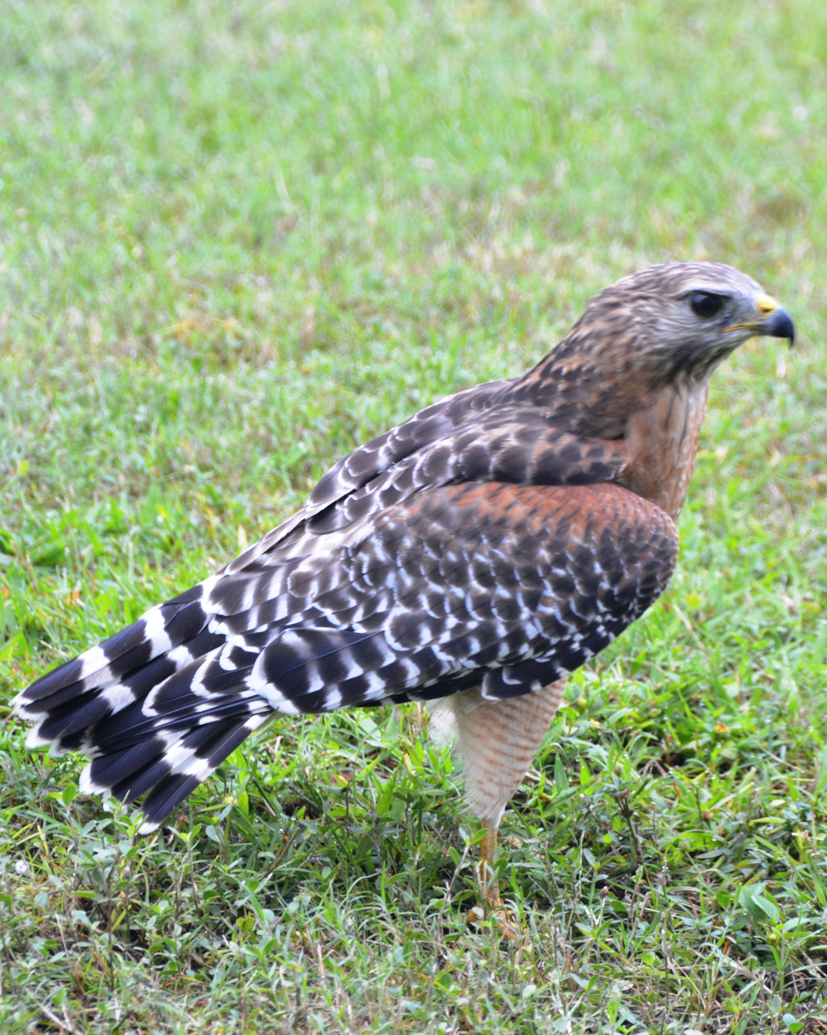
Spring 2016 Syllabus ID 196: CSUS-ISGP Fire and Water: Impacts of Climate Change Conference Development, Preparation and Evaluation
Instructor: Dr. Michelle Stevens, Environmental Studies Department
Office: 555B Amador
Telephone: 916-765-7397
ENVS Office: 278-2914
E-mail: stevensm@csus.edu
Course Schedule: MW 4:30-5:45
Location: 110 Douglass Hall
Office Hours: Tues 3-5pm, Thurs 3-4pm, or by appointment

Photo Credit: Andrew Hawkins

Course Description
“Fire and Water: Impacts of Climate Change” is an inter-disciplinary course designed to professionally train and mentor 15 students to participate in and assist with preparation for a CSUS-Institute on Science for Global Policy (ISGP) Climate Change Conference held April 10 & 11, 2016, on the CSUS campus. The course offers students the opportunity to create, prepare for, participate in, and evaluate a professional conference affiliated on campus. Students collaborate using a multidisciplinary, interactive approach to research and select conference topics and speakers. Students will participate in all aspects of the delivery of the conference including post-conference evaluation.

Prerequisite
Permission of Instructor

Textbook & Course Materials
No textbook required. Course reading materials will be provided via electronic media. Readings and other information related to the course will be made available on Blackboard (SacCT) and/or the relevant conference website for planning.
Course Requirements
- Internet connection (DSL, LAN, or cable connection desirable)
- Access to SacCT/Web site/Other
- Access to document sharing or other communication tools (e.g. Google Docs, Dropbox)
- Access to blog sites (e.g. Blogspot.com)

Course Structure
The course will include regular meeting patterns involving guest speakers and class discussions on assigned reading materials. Class requirements will include attendance at conferences or lectures and engagement with stakeholders in the public, scientific and policy communities on the selected conference themes. Students will be trained to conduct scientific and policy research, conduct phone interviews with national and regional experts, and assist with the final selection of conference speakers and if applicable, conference debaters. Students will collaborate on writing speakers papers on conference themes for dissemination to participants prior to the conference. Students are also required to actively participate in both a required mock conference and actual conference culminating in a written publication from the conference on areas of consensus, actionable next steps and public policy recommendations.

Primary Course Learning Objectives
Objective 1: Students will demonstrate an understanding of the process involved in developing a theme and the selection of related thematic topics for a conference.
Objective 2: Students will learn to critically evaluate policy and research in subject areas related to a conference theme and identify experts in these areas.
Objective 3: Students will demonstrate effective oral and written communication skills as conference developers, organizers, and active participants.
Objective 4: Students will develop skills to work collaboratively and use an interdisciplinary approach in the creation, development and implementation of a conference.
Objective 5: Students will learn to evaluate the success and perceived value of a conference using a variety of assessment approaches.

Teaching Philosophy: In this class you will experience different personalities; ways of thinking and expressing yourself; different backgrounds, cultures and ideas. All of your ways of being are embraced in my class, and evaluated through critical thinking skill development. Many of you love to play video games and are linear thinkers. This is particularly true if you are an engineer or engage in quantitative analyses as part of your major. Consider the differences between Powerpoint and Prezzi. Linear thinkers are analogous to Powerpoint. I am more similar to Prezzi. I will pull a lot of different ideas together in a circular way of thinking and integrate them all at the end. Some of you will have this same thinking style. Be aware that if you lose the thread of my lecture or argument, you are welcome to ask for clarification. Also be aware that I encourage and enjoy alternative points of view, and different ways of expressing and experiencing the world. We’ll look at this in class, it should be fun!
Secret to Success - Build Rapport and Build Community: If you find that you have any trouble keeping up with assignments or other aspects of the course, make sure you let your instructor know as early as possible. Please come to office hours or email me at stevensm@csus.edu, I am here to help you as best I can. As you will find, building rapport and effective relationships are key to becoming an effective professional. Make sure that you are proactive in informing me if difficulties arise during the semester so that I can help you find a solution.

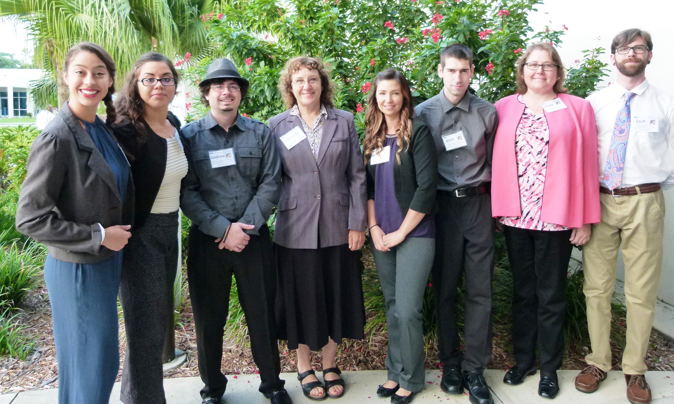
Class Schedule

This is the first time a climate change conference has been conducted on Sac State Campus. This schedule will definitively change. I will make announcements of schedule changes on Sac CT and email you when this occurs.
Class Schedule: This schedule is subject to change. We all need to do adaptive management, be resilient, plan ahead to get jobs done, and be Phoenix Rising, a team. We will have challenges, we face them, and we deal. That’s the strategy for success.

DATE | TOPIC | READING MATERIAL | ASSIGNMENT
Jan 25 | Introduction to Water and Fire: Impacts of Climate Change Conference | Intro to Climate Change Conference and Phoenix Rising Team | Self Assessment, In class and Take Home Short Essays
Jan 27 | Climate Change Lecture and Discussion | - Lecture on Climate Change Sac CT  - Read/ Review basic ENVS text ch on climate change | Take Home Short Reflective Essays Due
Feb 1 | Climate Change Guest Speaker Jim Wanket, Geography Dept | - Wanket Reading 1  - Wanket Reading 2 | Blog Entry 1  - One Page Outline and 3 questions for both Paper 1 AND Paper 2
Feb 3 | Required Conference Visualization and Team Building Meeting 4:30-6:30 Feb 3 – Meet in Deans Conference Room 256 Amador Hall (Pizza provided) |  | Vision, Mission and Goals Statement
Feb 8 | Climate Change: Fish and Water, Dr. Tim Horner, Geology Dept | Reading TBA | Blog Entry 2
Feb 10 | Water Footprint, Dr. Julian Fulton, ENVS | Reading TBA
Feb 15 | TBA | Reading TBA | Blog Entry 3
Feb 17 | TBA | Reading TBA
Feb 22 | International Perspective Speaker – Dr. Thomas Krabacher, Geography Dept. | Reading TBA | Blog Entry 4
Feb 24 | Paris Climate Treaty Talks and Geo-Engineering – Mark Brown , Gov Dept | Reading TBA
Feb 29 | TBA |  | Blog Entry 5
March 2 | TBA | Reading TBA
March 7 | Preparation for Mock Conference |  | Blog Entry 6  Prepare Questions – 1) Fire; 2) Water; 3) Fish & Research
March 9 | Required Mock Conference, 4:30-8:30, pizza provided Room??? | Dr. Sweta
March 14 | Group Preparation for Debate March 16 - Understanding the underpinning of the science and policy debate on climate change - Critical Thinking and Reading |  | Blog Entry 7  Group and background preparation
March 16 | Myth Buster Discussion/ Debate - Pros and Cons of whether climate change is anthropogenic |  | In Class Discussion, Written Assignment
March 21-25 | SPRING BREAK | NO CLASS | Blog Entry 8  May still need some help with paper preparation for three presenters
March 28 | Environmental Economics - Guest Speaker Jonathan Kaplan√
March 30 | Preparation of Topic Papers for Conference |  | Blog Entry 9
April 4 | Preparation of Topic Papers for Conference
April 6 | Conference Preparation |  | Blog Entry 10
April 9 | Required Conference Preparation | Workshop questions for caucus; training; meeting with George Archibald and staff
April 10 | Conference Participation | Participate as debaters at conference table, | Blog Entry 11
April 11 | Conference Preparation | scribes in caucus groups, participation in plenary session
April 13 | Synthesis of Areas of Consensus and Actionable Next Steps |  | Blog Entry 12  Celebrate Success
April 18 | Write up results and analysis of conference
April 20 | Write up results and analysis of conference |  | Blog Entry 13
April 25 | Write up results and analysis of conference
April 27 | Write up results and analysis of conference |  | Blog Entry 14
May 2 | Write up results and analysis of conference
May 4 | Write up results and analysis of conference |  | Blog Entry 15
May 9 | Write up results and analysis of conference
May 11 | Write up results and analysis of conference |  | Blog Entry 16
May | Final Meeting Time |  | Final Reflective Essays Due

ID 196: Conference Development and Evaluation –

COURSE REQUIREMENTS

1. Class Participation - Class attendance, including being on time, is heavily weighted in this grade. 20%
2. Weekly Personal Reflection - Blog 10% You must make entries to this blog once per week suggested on the date due. In some cases I will post prompts for the blog, in others you are describing your experiences and things you learn in the class. These are public and represent CSUS, and must be professional. We will self-police entries, and if something seems inappropriate for CSUS I’ll bring to your attention.

3. SHORT ESSAYS, QUIZZES, HOMEWORK, READING RESPONSES – Students will turn in a (minimum of) one-to-two page paper evaluating and integrating required readings. Students will also include 1-3 questions for readings, to practice for the conference. There are two types of essays: 1) reflective essays where you think through and comment from a first person narrative perspective; and 2) scientific or policy evaluations of readings with references and more formal scientific writing approach

4. Participation in social media – live feed facebook, twitter, etc. 5%

5. Oral Communication and Presentations 20%

6. Writing and Critical Analysis – Written summaries and critical assessments of class materials; writing three debate papers for conference; and participating in summary and publication of conference proceedings 20%

7. Assessment – Development of assessment tools and implementation of conference assessment
- Scientific and policy research – Production of reading summaries and discussion questions

• • HOMEWORK, QUIZZES AND OTHER ASSIGNMENTS 10%
Graded Course Activities

• Points | Sample Description
30% | Participation (class discussions, weekly blogs, social media, group presentations, conferences)(Learning Objectives #1-5)
20% | Oral Communication and Presentations – Phone interviews with conference participants, group projects/ presentations, and engagement in conference (Learning Objectives #3 and 4).
20% | Writing and Critical Analysis –(Learning Objectives #2, 3 and 4).
15% | Assessment: Development and Implementation of conference assessment tool (Learning Objectives #3 and 5).
15% | Scientific and Policy Research  (Learning Objectives #2 and 3).
 | Total Points Possible

E-mail: I welcome questions and comments via email. I do not accept assignments via email unless specifically requested in that format.

Expectations for Successful Participation in Course:
- To be successful in this course, students will function as a team. There will be a collective effort in this course to prepare for and participate in the selected conference on the CSUS Campus. Students must work both collaboratively and assume individual responsibility to participate in all aspects of conference preparation, implementation, and post-conference assessment and publication.

- Both the course instructor and related conference staff will be available throughout the semester to work directly with students to prepare them for the conference. This preparation includes learning to make phone interviews for conference speakers, critical assessment and preparation of conference materials, and actively participating as conference debaters.

Course Etiquette:

• Be on time. You will receive 25% deduction for 15 minutes late, 50% deduction for 30 min late, 45% deduction for 45 minutes late, and zero points after that. If you are late or miss class for a good reason, you need to text or email me before class to be excused.

• Be respectful to me and your fellow students. Disrespectful or inappropriate behavior will result in you being excused from class.

• Private conversations, cross-talk and texting during class are disruptive to other students in the class and will not be tolerated.

• A note about using electronic devices during class: I strongly discourage the use of electronic devices for social purposes during class. In order to do well in this course and get the most out of lectures, this time should be spent learning and participating in the class. Use of electronic devices for non-academic purposes during class will result in loss of participation points.

Build Rapport:

If you find that you have any trouble keeping up with assignments or other aspects of the course, make sure you let your instructor know as early as possible. As you will find, building rapport and effective relationships are key to becoming an effective professional. Make sure that you are proactive in informing your instructor when difficulties arise during the semester so that they can help you find a solution.

Viewing Grades in SacCT:
Points you receive for graded activities will be posted to the SacCT Grade Book. Click on the My Grades link in the navigation window on the left to view your points.

Letter Grade Assignment
Final grades assigned for this course will be based on the percentage of total points earned and are assigned as follows:
Letter Grade | Percentage | Performance
A | 93-100% | Excellent Work
A- | 90-92% | Nearly Excellent Work
B+ | 87-89% | Very Good Work
B | 83-86% | Good Work
B- | 80-82% | Mostly Good Work
C+ | 77-79% | Above Average Work
C | 73-76% | Average Work
C- | 70-72% | Mostly Average Work
D+ | 67-69% | Below Average Work
D | 60-66% | Poor Work
F | 0-59% | Failing Work
Important note: For more information about grading at Sac State, visit the academic policies and grading section of the university catalog.SSIS

Course Policies

Attend Class Students are expected to attend all class sessions as listed on the course calendar. Attendance is required, and the participation component of the class grade will reflect this requirement.

Participation Class participation will be monitored and based upon evaluation of the quality of your in-class participation in discussions and debates; completion of assigned blog posts; and active participation in the mock conference and climate change conference. Participation grades will also be assessed based on punctuality and completing assignments by the required due date.

Complete Assignments Assignments must be submitted by the given deadline or special permission must be requested from instructor before the due date. Extensions will not be given beyond the next assignment except under extreme circumstances.
All discussion assignments must be completed by the assignment due date and time. Late or missing discussion assignments will affect the student’s grade.
Understand When You May Drop This Course It is the student’s responsibility to understand when they need to consider disenrolling from a course. Refer to the Sac State Course Schedule for dates and deadlines for registration. After this period, a serious and compelling reason is required to drop from the course. Serious and compelling reasons includes: (1) documented and significant change in work hours, leaving student unable to attend class, or (2) documented and severe physical/mental illness/injury to the student or student’s family.

Incomplete Policy Under emergency/special circumstances, students may petition for an incomplete grade. An incomplete will only be assigned if serious and compelling reasons prevent a student from participation in the course. Since this is a high impact learning, experiential education course, that is only offered once, the reason for an incomplete would need to be an emergency situation.

Inform Your Instructor of Any Accommodations Needed Disability Information I am very sensitive to students with diagnosed learning disabilities; please discuss with me privately. If you have a documented disability and verification from the Office of Services to Students with Disabilities (SSWD), and wish to discuss academic accommodations, please contact me as soon as possible. If you have a disability and require accommodations, you will need to provide disability documentation to SSWD, Lassen Hall 1008. They can be contacted by phone at (916) 278-6955 (Voice) (916) 278-7239 (TDD only) or via email at sswd@csus.edu. It is the student’s responsibility to provide documentation of disability to SSWD and meet with a SSWD counselor to request special accommodation before classes start.

Commit to Integrity As a student in this course (and at this university) you are expected to maintain high degrees of professionalism, commitment to active learning and participation in this class and also integrity in your behavior in and out of the classroom.

Sac State's Academic Honesty Policy & Procedures “The principles of truth and honesty are recognized as fundamental to a community of scholars and teachers. California State University, Sacramento expects that both faculty and students will honor these principles, and in so doing, will protect the integrity of academic work and student grades.”
Read more about Sac State's Academic Honesty Policy & Procedures

Definitions At Sac State, “cheating is the act of obtaining or attempting to obtain credit for academic work through the use of any dishonest, deceptive, or fraudulent means.”
“Plagiarism is a form of cheating. At Sac State, “plagiarism is the use of distinctive ideas or works belonging to another person without providing adequate acknowledgement of that person’s contribution.”
Source: Sacramento State University Library
Important Note: Any form of academic dishonesty, including cheating and plagiarism, may be reported to the office of student affairs.
Course policies are subject to change. It is the student’s responsibility to check SacCT for corrections or updates to the syllabus. Any changes will be posted in SacCT.

